Calendar of Events 2021-2022
September 2021

01 - Wednesday Staff Training Day / INSET DAY 1
02 - Thursday Staff Training Day / INSET DAY 2
03 - Friday Staff Training Day / INSET DAY 3
06 – Monday Pupils return to school
17– Friday Jeans for Genes Day – Non-Uniform
22- Wednesday College Information Event Y10-Y11 - 5-8pm
24 - Friday MacMillan Coffee Morning
29 – Wednesday Parents’ Evening - 5-8pm

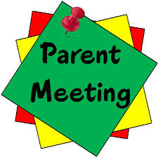 | October 2021  21 - Thursday Hallowe’en Disco - 5-7pm - Cancelled  22 – Friday Queen’s Platinum Jubilee Bank Holiday  Monday 25 – Friday 29 Oct (inclusive) Mid Term Closure
November 2021
01 - Monday Pupils return to school
04 –Thursday Diwali Celebrations
10 – Wednesday Children in Need
11 - Thursday Remembrance Day
12 –Friday Non-Uniform Day (Christmas Bingo Donations)
19 - Friday Non-Uniform Day (Christmas Bingo Donations)
19 – Friday Anti-Bullying Day
26 - Friday Non-Uniform Day (Christmas Bingo Donations)
30 – Wednesday Saint Andrew’s Day

December 2021

02 – Thursday Christmas Bingo - 6-8pm
08 - Wednesday Primary Christmas Dinner / Secondary Christmas Parties
09 – Thursday Be Internet Legends Day
09 - Thursday Secondary Christmas Dinner / Primary Christmas Parties
10 - Friday Christmas Jumper Day
13 - Monday Primary Christmas Show
14 - Tuesday Secondary Christmas Show
15 - Wednesday Breakfast with Santa - 9:30am
17 - Friday School Closes for Christmas – 3:15pm
Monday 20 December – Monday 4 January (inclusive)
Christmas Holiday

January 2022
04 – Monday Staff Training Day / INSET DAY 4
05 - Wednesday Pupils return to school
10 – Monday Tempest Photographer
17 – Monday World Religion Day

February 2022
01 - Tuesday Chinese New Year Celebration
08 - Tuesday Safer Internet Day
10 – Thursday Valentine’s Disco 5-7pm
Monday 14 – Friday 18 February (inclusive) Mid Term Closure

21 - Monday Pupils return to school
March 2022
01 –Tuesday Saint David’s Day
03 - Thursday World Book Day
08 –Tuesday International Women’s Day
11 –Friday Non-uniform (Easter egg donations please)
17 –Thursday Saint Patrick’s Day
18 –Friday Non-uniform (Easter egg donations please)
18 –Friday Red Nose Day
21 - Monday World Down Syndrome Day
24 –Thursday Easter Bingo 6pm-8pm
25 –Friday World Epilepsy Day ‘Wear Purple’

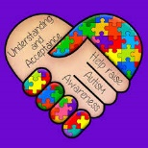 |  | Monday 04 – Monday 18 April (inclusive) Mid Term Closure  April 2022  01 –Friday World Autism Awareness Day (2 April) 19- Tuesday Passover – Jewish Festival 19 –Tuesday Pupils return to school 22 - Friday Saint George’s Day 29 –Friday Staff Training Day / Inset Day 5
Monday 30 – Friday 3 June (inclusive) Mid Term Closure
May 2022
02 –Monday May Day Bank Holiday 03 - 05 Eid Celebrations 13 – Friday Mental Health Awareness Day 16 - Monday Wesak – Buddha Day 27 –Friday Non-Uniform Day (Summer Fair) 27 –Friday Queen’s Platinum Jubilee Celebrations

June - LGBT - Pride Month
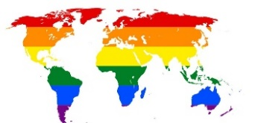 |  | June 2022  06 - Monday Pupils return to school  10 - Friday Non-Uniform Day (Summer Fair)  17 - Friday Non-Uniform Day (Summer Fair)  17 - Friday Annual reports  17 –Friday Rainbow Day  18 - Saturday Summer Fair 10am – 2pm  w/c 20 Sports Week  21 –Tuesday Parents’ Evening – 5-8pm  24 - Friday Primary Awards Assembly / Year 6 Graduation -10am
July 2022  08 - Friday Secondary Awards Assembly – 10am  12 –Tuesday Primary Meet and Greet – 4-7pm  14 –Thursday Secondary Meet and Greet – 4-7pm  15 - Friday Year 11 Graduation – 10am / Year 11 Leaving Day  w/c 18 Transition to new classes  22 - Friday School closes to pupils  Summer Holiday |  |  |  |  | 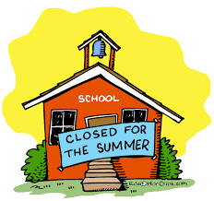
School Re-opens to Pupils - Monday 05 September 2022

